Third’s Word

**World Teachers Day**

We Celebrated world Teachers Day on 2nd October. Teachers were relieved by little teachers teaching the younger grades. We went to FS to teach 2D

**Active Classroom Learning**

**Literacy: -** We learnt how to write a report on garden birds, Verb Tenses, Speaking loud and clear and speech verbs.

**Numeracy: -** We learnt three digit numbers, addition facts of 10 and 20,2D shapes, length and now we know to tell the time.

**Geography: -** We enjoyed learning about, how hot and cold places are and about the Changing scene.

**Science: -** We got the opportunity to learn and understand a lot more aboutrocks and its properties. We conducted various experiments and observations on rocks and soils. We are currently learning about Helping plants grow.

**History: -** We are learning about Ancient Greek Architecture. And about archeology.

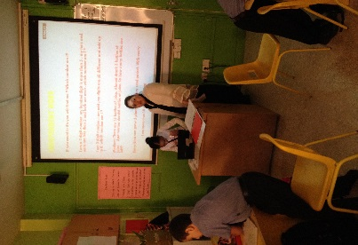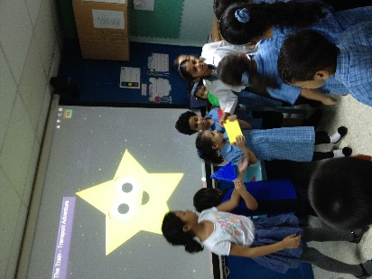

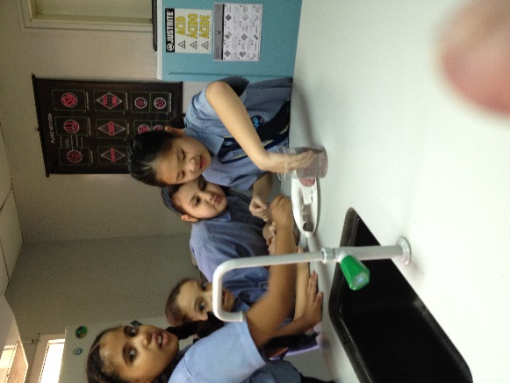

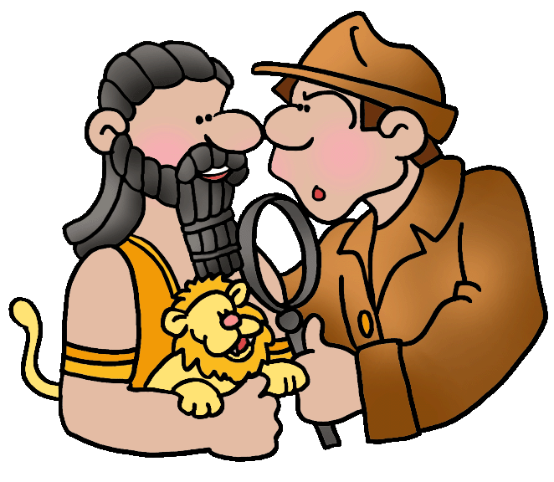

**Class Blog**

Visit our class blog and find the happenings.

[www.3ftalks.weebly.com](http://www.3ftalks.weebly.com)

**SEWA**

The concept of SEWA –‘SELFLESS SERVICE’ was integrated in daily To help relieve hardship & poverty; To promote environmental preservation; and To bring a little joy to others. The 3 principles of SEWA was thought through different subjects and assemblies.

ATTENDANCE SUMMARY October 2014

