The Westminster School, Dubai

Counting in 1s, 10s, 50s and 100s

Name: ________________ Date: _________________

Write the next three numbers.

1) 40, 41, 42, _____, ______, _____ 2) 71, 72, 73, _____, ______, ______

3) 420, 430, 440, ______, ______, ______ 4) 150, 160, 170, ______, _______, ______

How many times have the children run up and down if they have:

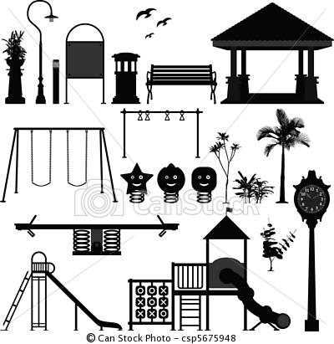

100

a) 400 m _______ b) 500 m _______ c) 1300 m ______ d) 1000 m ________

Each bag has 100 clips. How many clips are there on each box?

C:\Users\Mariya.SCHOOL\AppData\Local\Microsoft\Windows\Temporary Internet Files\Content.IE5\1IRG8UGL\MC900391290[1].wmfC:\Users\Mariya.SCHOOL\AppData\Local\Microsoft\Windows\Temporary Internet Files\Content.IE5\1IRG8UGL\MC900391290[1].wmfC:\Users\Mariya.SCHOOL\AppData\Local\Microsoft\Windows\Temporary Internet Files\Content.IE5\1IRG8UGL\MC900391290[1].wmfC:\Users\Mariya.SCHOOL\AppData\Local\Microsoft\Windows\Temporary Internet Files\Content.IE5\1IRG8UGL\MC900391290[1].wmf

1)

___________ _____________ ______________ ___________

Each bag holds 50 candies. How many candies?



___________ ___________ ___________