

**The Westminster School, Dubai**

**2014-15**

**Year: 3** **Topic:** **Greek Food Habits Date: 24.2.15**

Clay was a very important part of ancient Greek culture. Back then, they did not have glass or plastic to make containers out of. Luckily clay was easy to find in Greece. Once clay is fired it is almost indestructible (unless broken) and also fairly waterproof. These features made clay a perfect material to make containers out of. It was used for big storage containers, buckets, cups, perfume bottles, wine bottles, jewellery boxes, and any other type of container for storing things in. All of these uses made the potters in ancient Greece very busy.

Most Greek pottery was shaped for a particular function or a number of functions. They were used around the house, or for ceremonies, or even entertainment. The Greeks thought of the pots as if they were people, too. They used human terms to describe parts of the pots. For example - handles were called ears and bases were called feet. Today, we continue to use some of the terms like mouth, lip, neck, shoulder, and body. The mouth is the opening at the top. The lip is the edge of the pot right around the mouth. Below the lip is the neck. The shoulder is where the neck expands to the size of the body and the body is the main part of the pot.

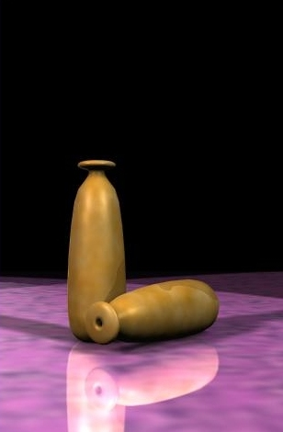

1 Alabastron : This is a small vase for perfume or oil .It had a broad flat mouth, a narrow neck, and a thinly made body. A dipstick was used to get the contents out.

*[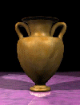](http://atschool.eduweb.co.uk/sirrobhitch.suffolk/portland%20state%20university%20greek%20civilization%20home%20page%20v2/docs/13/amphorae.htm)*

2Amphora: Meaning to carry on both sides. They always have two vertical handles, a wide body, and a narrow neck. They come in all sizes and some even have lids. They were used to store and transport liquids, like water and wine, and solids, like [grain and olives](http://atschool.eduweb.co.uk/sirrobhitch.suffolk/portland%20state%20university%20greek%20civilization%20home%20page%20v2/docs/6/lystrupm.html).

3. Hydria: The name Hydria is from the word hydor or 'water'. A hydria was used to fetch water. They usually have oval bodies, two horizontal handles, and one vertical handle.

[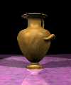](http://atschool.eduweb.co.uk/sirrobhitch.suffolk/portland%20state%20university%20greek%20civilization%20home%20page%20v2/docs/13/hydriai.htm)

4. Kraters: The name Krater is taken from a word meaning 'mix'. The pot was a large bowl used for mixing water and wine. Wine was then ladled into cups from the Krater.

5. Kylix: is a large wine cup with a shallow bowl. It has two horizontal handles. Attaching the bowl to the foot is a high stem.

*[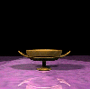](http://atschool.eduweb.co.uk/sirrobhitch.suffolk/portland%20state%20university%20greek%20civilization%20home%20page%20v2/docs/13/kylix.htm)*

*[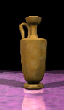](http://atschool.eduweb.co.uk/sirrobhitch.suffolk/portland%20state%20university%20greek%20civilization%20home%20page%20v2/docs/13/lekythoi.htm)*

6. Lekythos: This is an oil bottle. The name Lekythos is used conventionally to describe a pot that has a tall and squat shape, a foot, a single vertical handle, a narrow neck, and a small mouth.

*[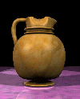](http://atschool.eduweb.co.uk/sirrobhitch.suffolk/portland%20state%20university%20greek%20civilization%20home%20page%20v2/docs/13/oinochoa.htm)*

7. Oinochoe: This pot's name means 'wine-pourer'. This jug was used to pour wine. It usually had one handle along its side.

*[](http://atschool.eduweb.co.uk/sirrobhitch.suffolk/portland%20state%20university%20greek%20civilization%20home%20page%20v2/docs/13/pyxis.htm)*

8. Pyxis: These boxes are round like a cylinder. They usually have lids. They were used to store toiletries such as cosmetics, powder, or even [jewellery](http://atschool.eduweb.co.uk/sirrobhitch.suffolk/portland%20state%20university%20greek%20civilization%20home%20page%20v2/docs/7/women.html).

9. Stamnos: This name is usually used to describe a pot that is used for storing and mixing. It has two small horizontal handles on its side. The body is rather round and it has a short neck.

*[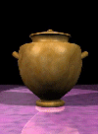](http://atschool.eduweb.co.uk/sirrobhitch.suffolk/portland%20state%20university%20greek%20civilization%20home%20page%20v2/docs/13/stamnos.htm)*