The Westminster School, Dubai
2014-15
Year : 3 Topic: Greek Schools Date: 6.1.15
Greek schools were small. They had only one teacher and about ten or twenty boys. The schools were not free and so only the rich could really afford to send their children to school. Most Greeks schools had only 20 boys, and classes were often held outdoors.
The children did not need much school equipment as they had to learn everything off by heart. When they needed to, they wrote on wooden tablets covered with soft layers of wax. They used a wooden pen called a stylus with a sharp end for writing and a flat end for 'rubbing out'. The wax was melted and reapplied from time to time. They used an abacus, with beads strung on wires or wooden rods, to help with maths.
Athens: Until age 6 or so, boys were taught at home by their mother or by a male slave. From age 6 to 14, boys went to a neighbourhood primary school or to a private school. Books were very expensive and rare, so subjects were read out-loud, and the boys had to memorize everything.
In primary school, they had to learn two important things - the words of Homer, a famous Greek epic poet, and how to play the lyre (small harps sounded something like a guitar). Their teacher, who was always a man, could choose what additional subjects he wanted to teach. He might choose to teach drama, public speaking, government, art, reading, writing, math, and how to play another ancient Greek instrument - the flute.
Following that, boys attended a higher school for four more years. When they turned 18, they entered military school for two additional years. At age 20, they graduated.
Girls were not educated at school, but many learned to read and write at home in the comfort of their courtyard.

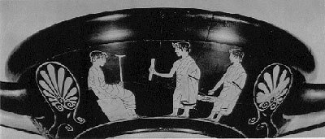

Sparta: Spartans believed in a life of discipline, self-denial, and simplicity. They were very loyal to the state of Sparta. Every Spartan, male or female, was required to have a perfect body.
When babies were born in ancient Sparta, Spartan soldiers would come by the house and check the baby. If the baby did not appear healthy and strong, the infant was taken away, and left to die on a hillside, or taken away to be trained as a slave (a helot).
Spartan boys were sent to military school at age 6 or 7. They lived, trained and slept in the barracks of their brotherhood. They were taught survival skills and other skills necessary to be a great soldier. School courses were very hard and often painful.
Although students were taught to read and write, those skills were not very important to the ancient Spartans. Only warfare mattered. The boys were not fed well, and were told that it was fine to steal food as long as they did not get caught stealing. If they were caught, they were beaten. The boys marched without shoes to make them stronger. It was a brutal training period.
