The Westminster School, Dubai
2014-15
Year : 3 Topic: Tally chart Date: 3.11.2014
- Look at the Pictograph and answer the questions.
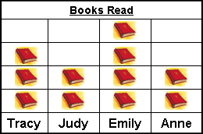
- Who read the most books?
- Who read the same number of books?
- How many books were read by Tracy?
- How many more books did Emily read than Tracy?
- How many less books did Judy read than Emily?
- What is the total number of books read by all four girls?

- Interpret this pictograph with the help of these questions.

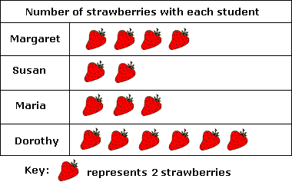
- How many Strawberries in all?
- Who had the least strawberries?
- Dorothy had the most strawberries. Say yes or no.
- Who had double the number of strawberries as Susan?
- How many more strawberries did Dorothy have than Maria?

