The Westminster School, Dubai
2016-2017
Year: 3 Topic: Tally chart Date: 13.11.2016
Objective :- To Interpret data using Tally tables.
- Look at the following tally charts and answer the questions.
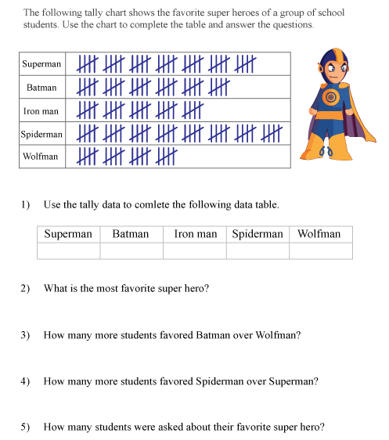
- Survey with your family members about their favourite fruit and create a tally table.

Answers:
1.
Superman | Batman | Iron Man | Spiderman | Wolfman
35 | 30 | 25 | 40 | 20

2. Spiderman
3. 10 Students
4. 5 Students
5. 150 Students

